[BULACAN POLYTECHNIC COLLEGE]
[Bachelor of Science and Information System]
CT-MAD 213 MOBILE APPLICATION DEVELOPMENT
FINAL PROJECT DOCUMENTATION

ZELORA
An E-Commerce Mobile Application for Customers, Sellers, Delivery Riders and Administrators
Category: Business Applications (E-Commerce Application) | Complexity: Intermediate
Submitted by:
Cabuz, Jewell Ace Jhay V.
Espino, Jerome M.
Eva, Angel T.
Isidro, Kristina Cassandra P.
Pascual, Leira, C.

Submitted to:
KYLE JOSEPH G. FABIAN

[10/24/2026]

1. PROJECT OVERVIEW

1.1 Project Description
Zelora is an e-commerce mobile application developed using Java that provides users with a convenient platform for online shopping. The application allows buyers to search and browse products, view product information, add items to their shopping cart, apply vouchers, select a shipping method, proceed to checkout, make payments, and monitor their orders.

The application connects different users involved in the e-commerce process, including buyers, sellers, administrators, and delivery riders. Buyers can browse and purchase products, sellers can process and manage orders, administrators can manage user accounts and system-related concerns, and delivery riders can handle delivery requests and shipments. Zelora also supports important e-commerce processes such as order processing, order cancellation, payment processing, inventory management, delivery management, rider tracking, and database management. The application aims to provide a convenient, organized, and user-friendly shopping experience through a mobile platform.

1.2 Problem Statement
Traditional shopping requires customers to physically visit stores, search for products, and complete purchases in person. This can be time-consuming and inconvenient, especially for customers who prefer using mobile devices for shopping. Sellers may also experience difficulties in managing customer orders, monitoring sales, handling payments, and coordinating deliveries when these processes are performed manually or through separate platforms.

The following problems are addressed by the system:
- Difficulty in searching and browsing products.
- Time-consuming traditional shopping processes.
- Difficulty in managing shopping carts and orders.
- Lack of a convenient mobile-based ordering platform.
- Difficulty in monitoring order status.
- Difficulty in cancelling orders when necessary.
- Challenges in coordinating deliveries.
- Difficulty in managing users and seller activities.
- Lack of an integrated platform connecting buyers, sellers, administrators, and delivery riders.
To address these concerns, Zelora provides an integrated e-commerce mobile application that combines shopping, ordering, payment, cancellation, and delivery-related processes in one platform.

Target Users

Buyers/Customers | Buyers are the primary users of Zelora. They can browse products, view product information, add products to their shopping cart, apply vouchers, select shipping methods, checkout, submit payments, monitor their orders, cancel eligible orders, and rate or review products.
Sellers | Sellers use the application to receive and process orders, ship products, monitor order status, view sales analytics, and manage seller-related activities.
Administrators | Administrators manage user accounts, handle disputes, and monitor important activities within the system.
Delivery Riders | Delivery riders handle delivery-related activities. They can receive delivery requests, accept or reject delivery jobs, navigate to the seller or hub, pick up orders, and confirm shipments.

1.3 Proposed Solution
The proposed solution is Zelora, a Java-based e-commerce mobile application that provides an integrated platform for online shopping. The application allows buyers to search and browse products, view product information, add products to their shopping cart, apply vouchers, select shipping methods, proceed to checkout, make payments, monitor orders, and cancel eligible orders.
The system also provides functions for sellers, administrators, and delivery riders. Sellers can process and ship orders, administrators can manage users and system concerns, while delivery riders can receive and complete delivery requests. Through these functions, Zelora aims to make the online shopping process more convenient, organized, and accessible.

2. OBJECTIVES, SCOPE AND FEATURES

2.1 General Objective
The general objective of the project is to develop a functional and user-friendly Java-based e-commerce mobile application called Zelora that integrates product browsing, shopping cart management, checkout, payment, order cancellation, order processing, and delivery management into one platform.

2.2 Specific Objectives
1. Develop a functional e-commerce mobile application using Java.
2. Provide users with an easy-to-use mobile shopping platform.
3. Allow buyers to search and browse available products.
4. Allow buyers to view detailed product information.
5. Allow buyers to add products to their shopping cart.
6. Allow buyers to apply available vouchers.
7. Allow buyers to select a shipping method.
8. Provide a convenient checkout process.
9. Support payment processing through a payment gateway, if implemented.
10. Allow buyers to monitor their order status.
11. Allow buyers to cancel eligible orders.
12. Allow buyers to rate and review purchased products.
13. Allow sellers to receive and process customer orders.
14. Allow sellers to ship orders and monitor sales.
15. Allow administrators to manage user accounts and system concerns.
16. Allow delivery riders to receive and manage delivery requests.
17. Store and manage important information through a database.
18. Provide an organized and convenient e-commerce experience.

2.3 Scope and Limitations
Scope.
Zelora covers the major processes involved in an e-commerce system.
Buyer Functions
The buyer can:
- Register an account.
- Log in to the application.
- Search and browse products.
- View product information.
- Add products to the shopping cart.
- Continue shopping.
- View and manage the cart.
- Proceed to checkout.
- Select a shipping method.
- Apply available vouchers.
- Initiate payment.
- Submit payment.
- Monitor order status.
- Cancel eligible orders.
- Receive order notifications.
- Rate and review products.

Seller Functions
The seller can:
- Receive order notifications.
- View customer orders.
- Process customer orders.
- Ship orders.
- Monitor order status.
- View sales analytics.
- Manage seller-related activities.
- Request settlement.

Admin Functions
The administrator can:
- Manage user accounts.
- Handle disputes.
- Monitor system activities.
- Manage delivery-related requests.

Delivery Rider Functions
The delivery rider can:
- Receive delivery requests.
- Accept or reject delivery jobs.
- Navigate to the seller or hub.
- Pick up orders.
- Navigate and optimize delivery routes.
- Acknowledge orders.
- Confirm shipments.

System Functions
The system includes:
- User authentication.
- Product browsing.
- Shopping cart management.
- Order processing.
- Order cancellation.
- Payment gateway integration.
- Rider tracking.
- Inventory control.
- Database management.

Limitations
The application may have the following limitations:
- Some functions may require an internet connection.
- Actual payment processing depends on the availability and implementation of a payment gateway.
- Real-time rider tracking may require location and internet services.
- Delivery route optimization may depend on mapping or location services.
- Product availability depends on information stored in the database.
- Order cancellation may only be available while the order is still eligible for cancellation.
- Some advanced e-commerce features may not be available in the current version.
- The application is primarily designed for Android mobile devices.
- System performance may depend on the user's device and internet connection.

2.4 Major Features
Role | Major features
All users | Sign up with role choice, login, forgot password (offline reset), persistent session, log out, account settings, Help Center and Terms and Conditions.
Customer | Home with search, category chips and sort; product detail with photo slider, colors, quantity, wishlist and share; wishlist; cart; checkout sheet with address, payment method (Card, GCash/Maya, Cash on Delivery) and voucher codes; My Orders with cancel while Processing, rate and review, report a problem; order status notifications.
Seller | Receive order notifications, view and process customer orders, ship orders, monitor order status, view sales analytics, manage seller-related activities, and request settlements.
Rider | Receive delivery requests, accept or reject delivery jobs, navigate to the seller or hub, pick up orders, navigate and optimize delivery routes, acknowledge orders, and confirm shipments.
Admin | Manage user accounts, handle disputes, monitor system activities, and manage delivery-related requests.

3. SYSTEM DESIGN
This section shows how Zelora is built. The architecture diagram shows the layers of the app, the process flow shows how a customer order moves through the system and the database, the order lifecycle shows which role moves an order at each step, the use case diagram shows what each role can do, and the ER diagram shows the SQLite database. The source files of all diagrams (Graphviz and draw.io) are in the project’s docs folder on GitHub.

3.1 System Architecture
The app has four layers. The presentation layer holds the screens (activities, fragments and adapters). The logic layer holds validation, password hashing, session handling and the notification helper. The data access layer (DAO classes and DatabaseHelper) is the backend: every SQL query is written there with parameters. The data is stored in an SQLite database on the phone, and small settings such as the logged-in user are kept in SharedPreferences.

System Architecture Diagram
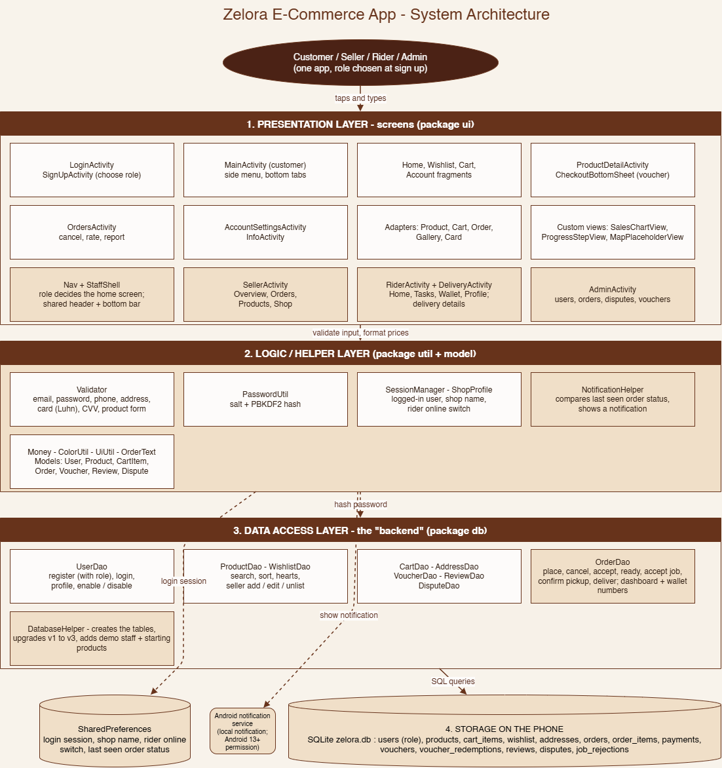

3.2 Application Process Flow
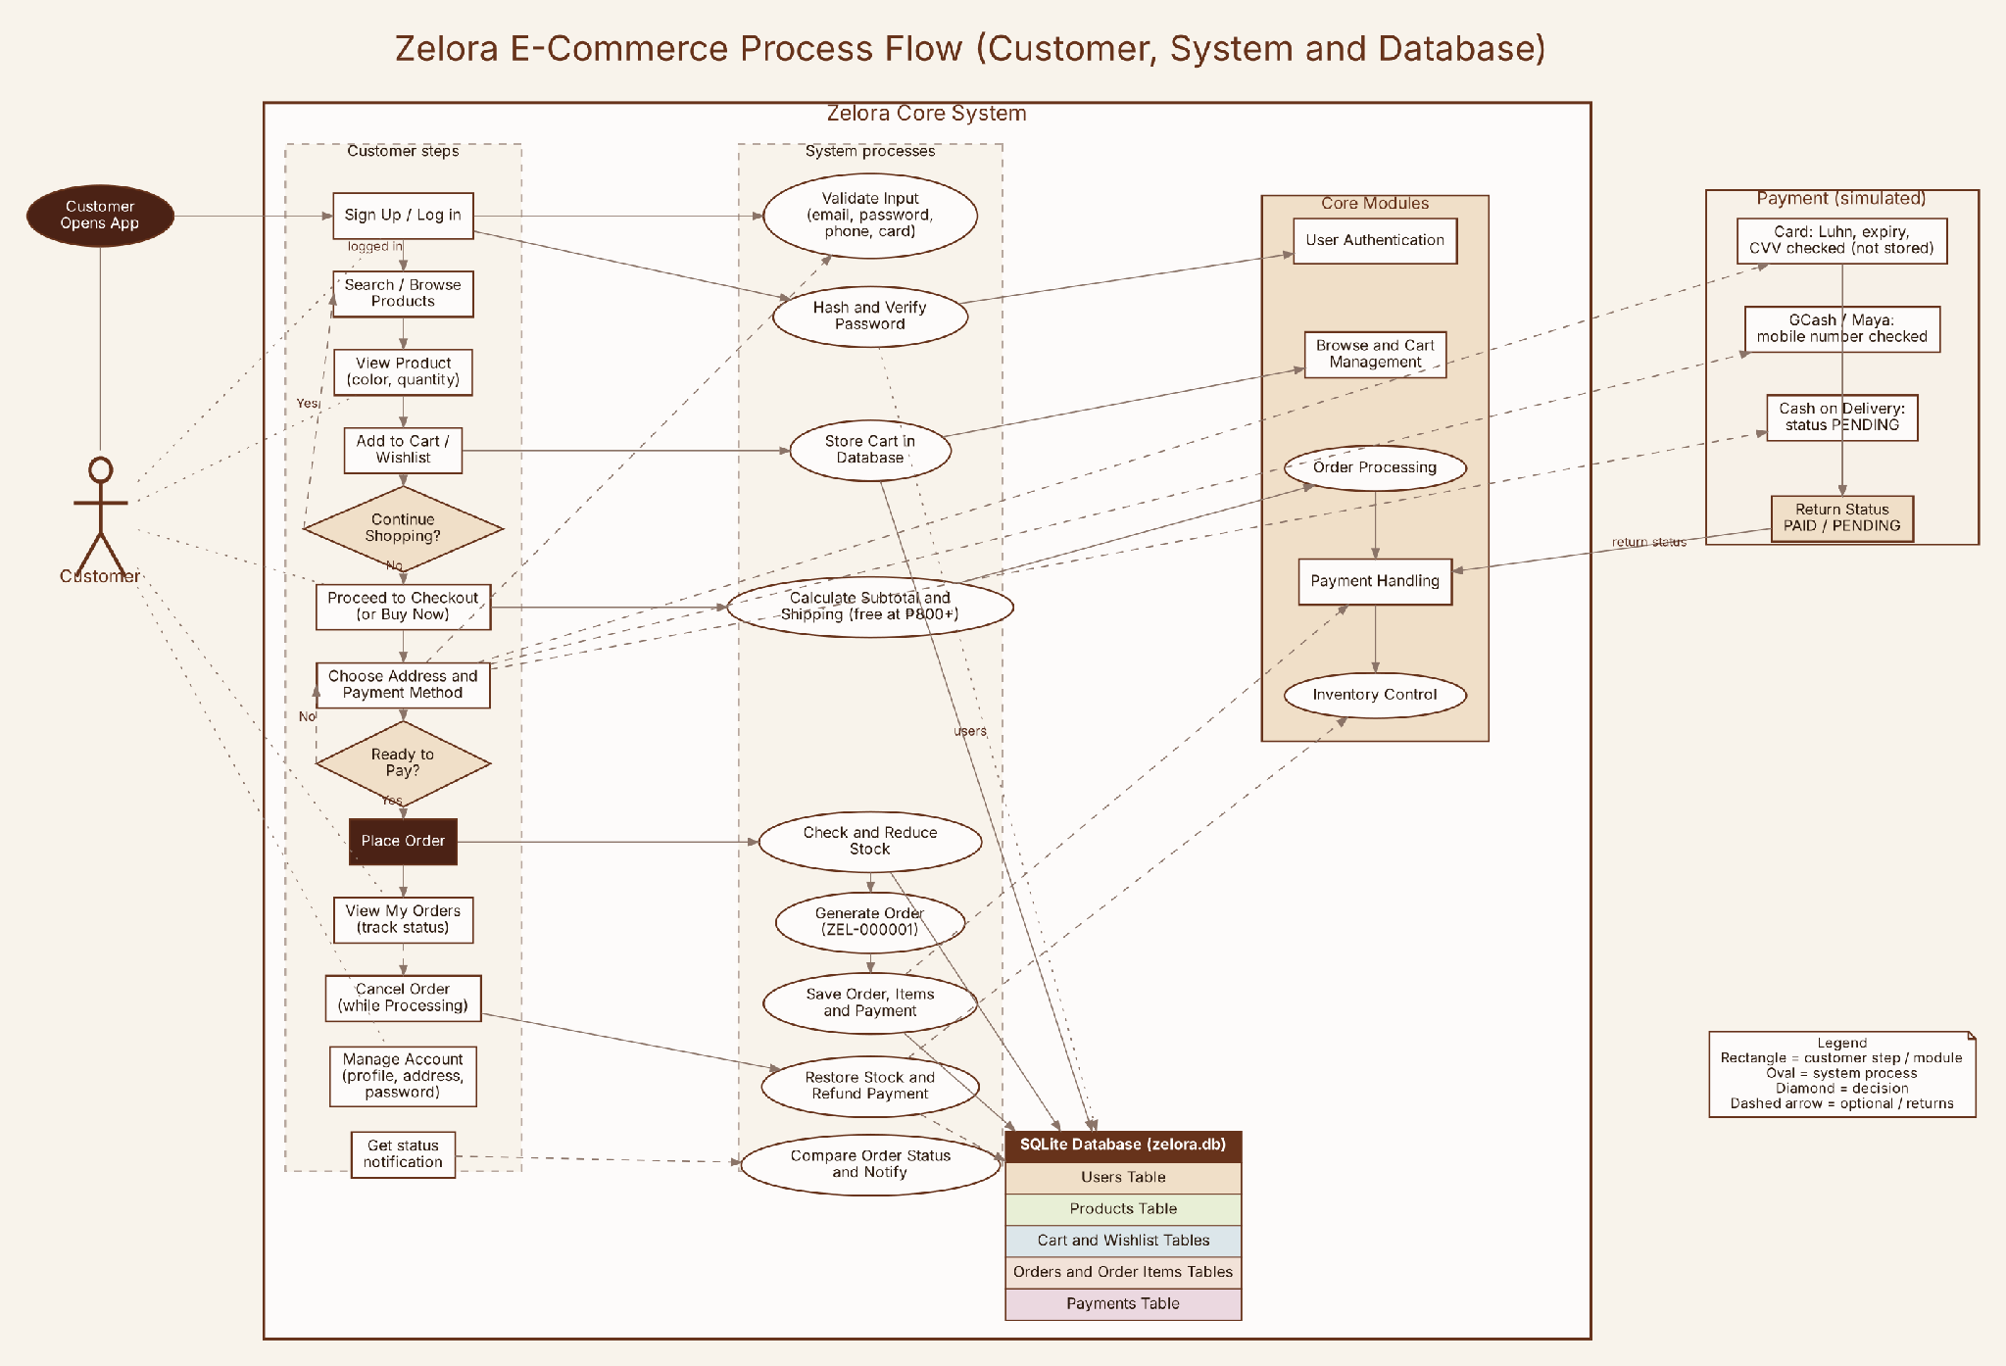
Figure 2. Process flow of the customer, the system processes and the SQLite database.

3.3 Order Lifecycle
An order is created as Processing. The customer can cancel only while it is Processing. The seller then accepts it (Preparing) and marks it ready (Packed). The first rider to accept the job takes it (Out for Delivery), confirms pickup, and marks it Delivered, at which point a Cash on Delivery payment becomes PAID. A customer can report a problem on a Packed, Out for Delivery or Delivered order, and the admin resolves, refunds or rejects the report.
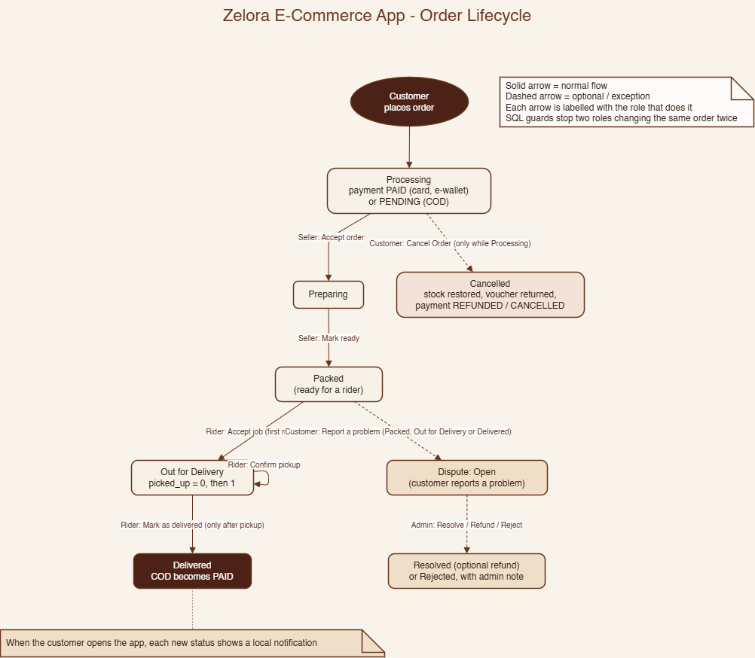
Figure 3. Order lifecycle: which role moves an order at each step.

3.4 Use Case Diagram (Seller, Delivery Rider and Admin)
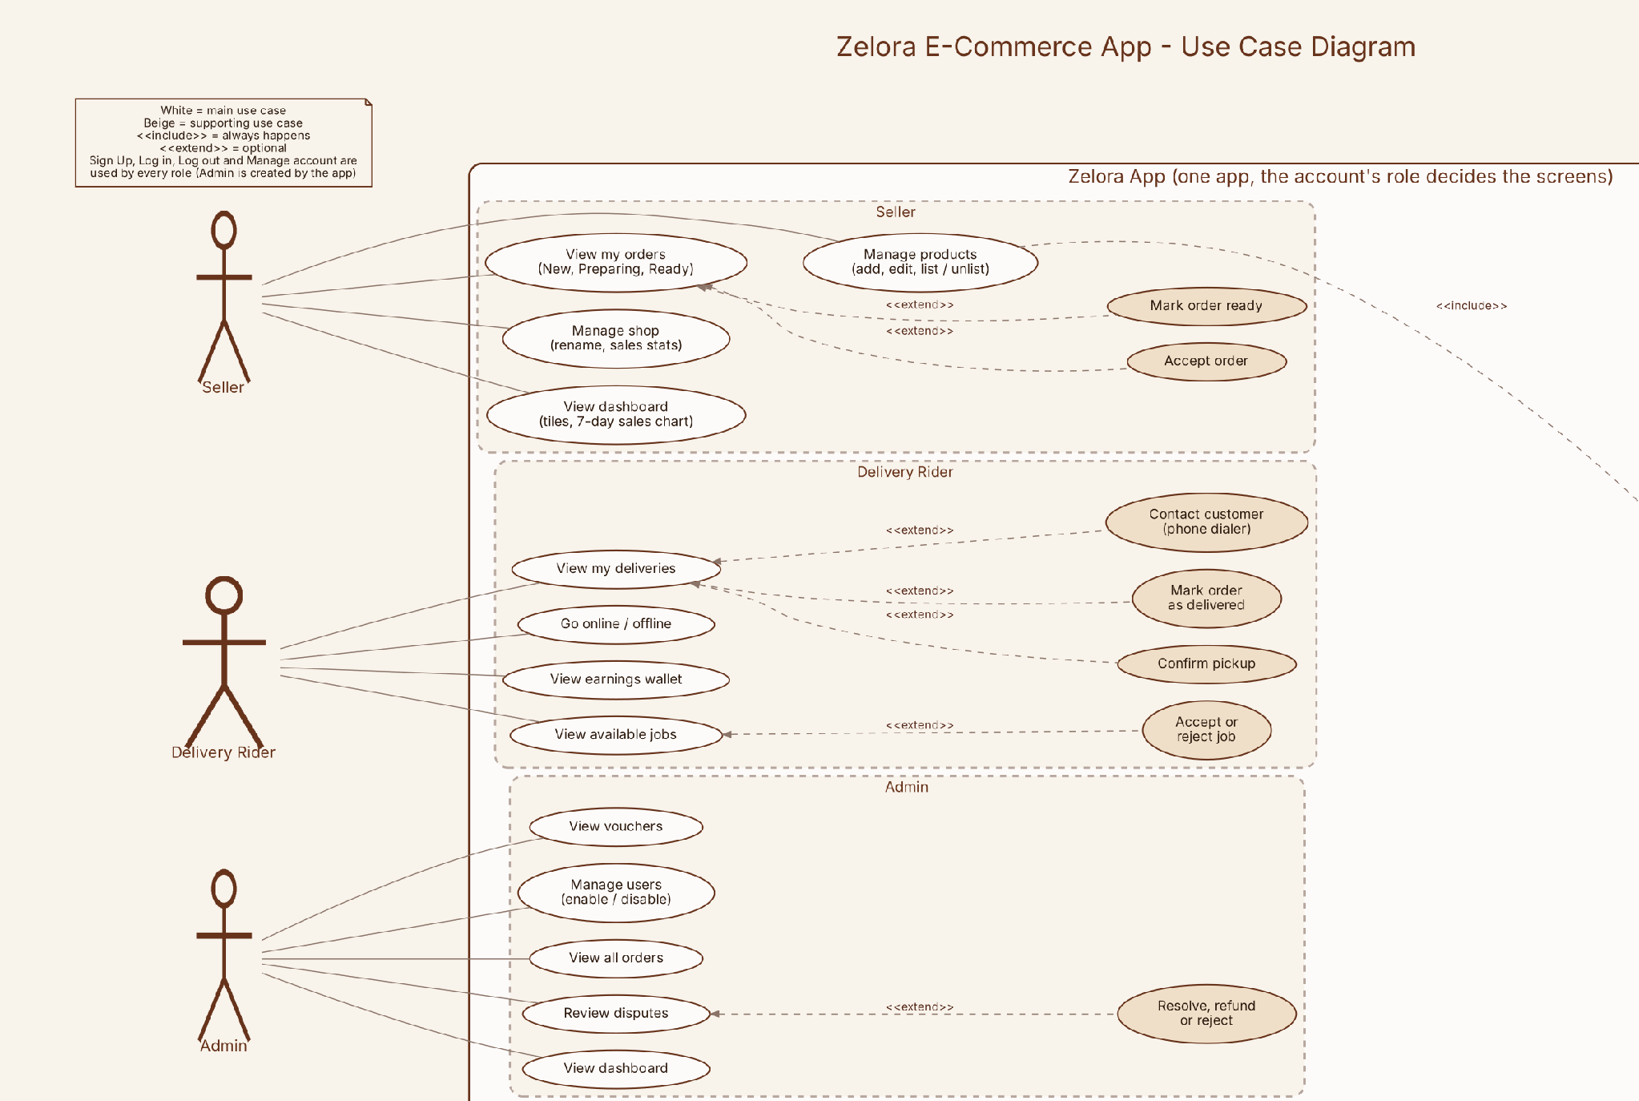
Figure 4. Use cases of the Seller, Delivery Rider and Admin.

Use Case Diagram (Customer and shared account use cases)

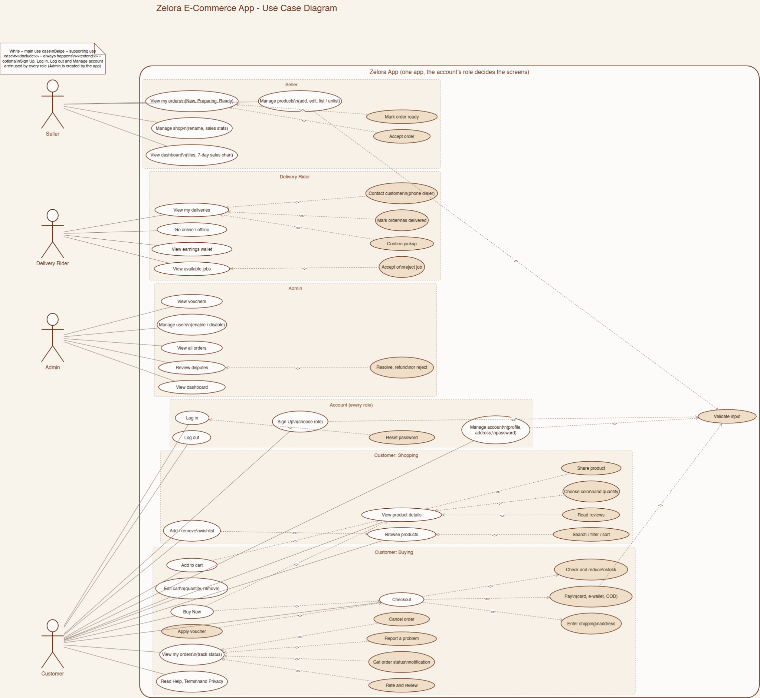
Figure 5. Use cases of the Customer and the account functions used by every role.

3.5 Entity Relationship (ER) Diagram
The database has 13 tables. users hold all four roles in the role column. products belong to a seller. orders belong to a customer and, once accepted, to a rider. order_items store the product name and price at the time of purchase, so later price changes do not change old orders.
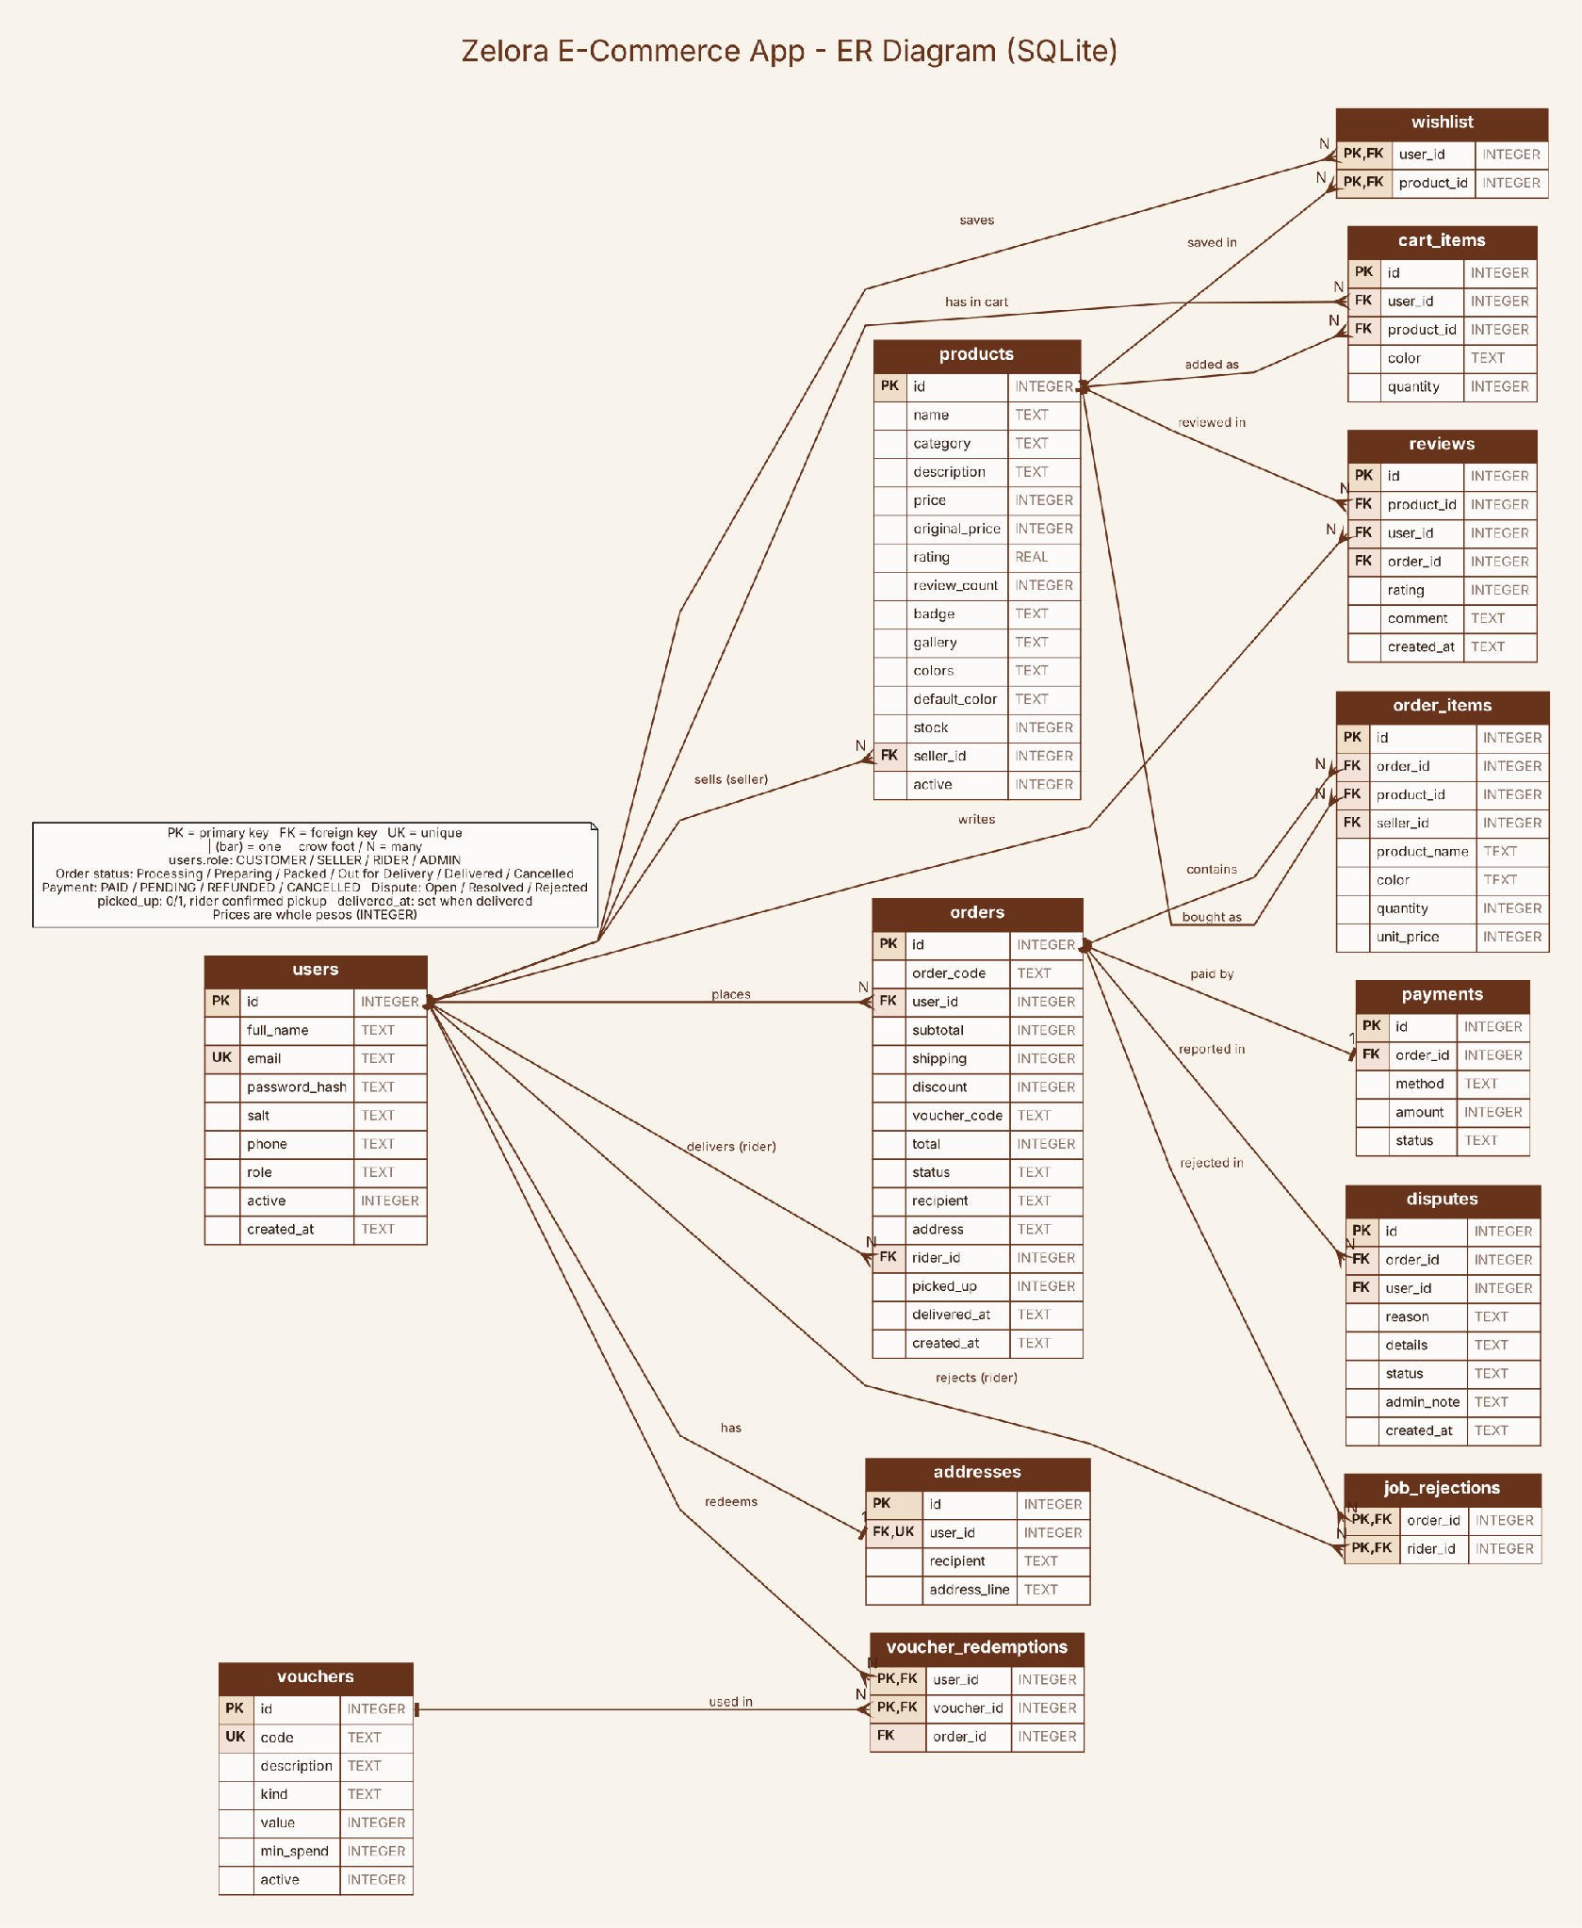
Figure 6. ER diagram of the Zelora SQLite database (zelora.db, version 3).

4. UI/UX AND IMPLEMENTATION

4.1 UI/UX Design
The UI/UX design of Zelora focuses on creating a user-friendly online shopping experience with a minimalist interface featuring warm cream backgrounds and dark brown accents. Utilizing Figma for mockups, the application organizes roles into Customer, Seller, Rider, and Admin, each with tailored interfaces. Customers can browse products and manage orders, Sellers monitor sales and manage listings, Riders handle deliveries, and Admins oversee user accounts and platform statistics. The design prioritizes consistency, readability, and ease of navigation, ensuring efficient task management for all users.

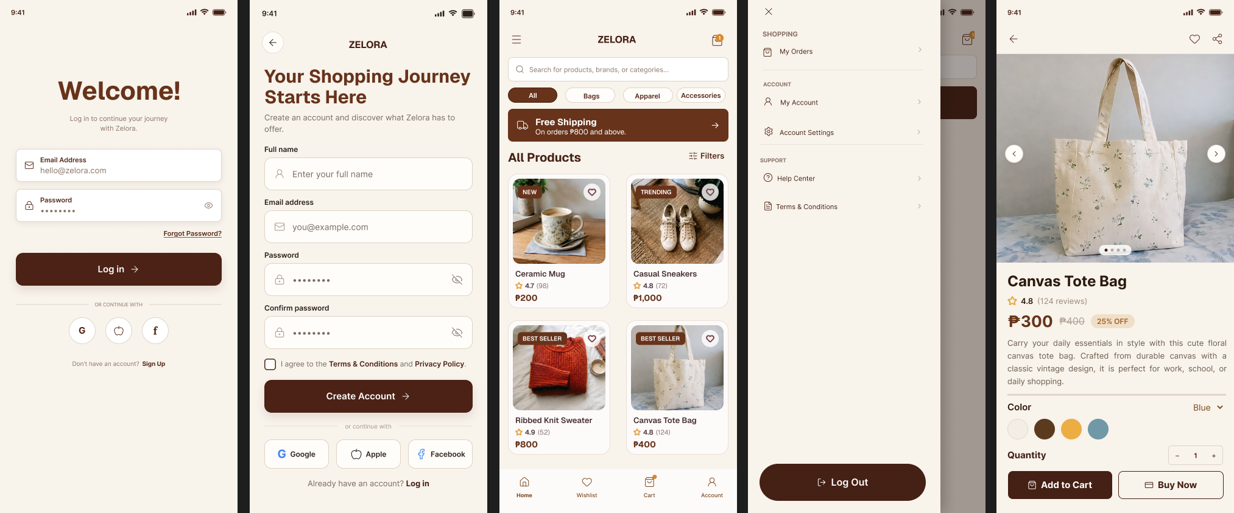
Figure 7. Mockups: Login, Sign Up, Home, Side menu and Product Detail.
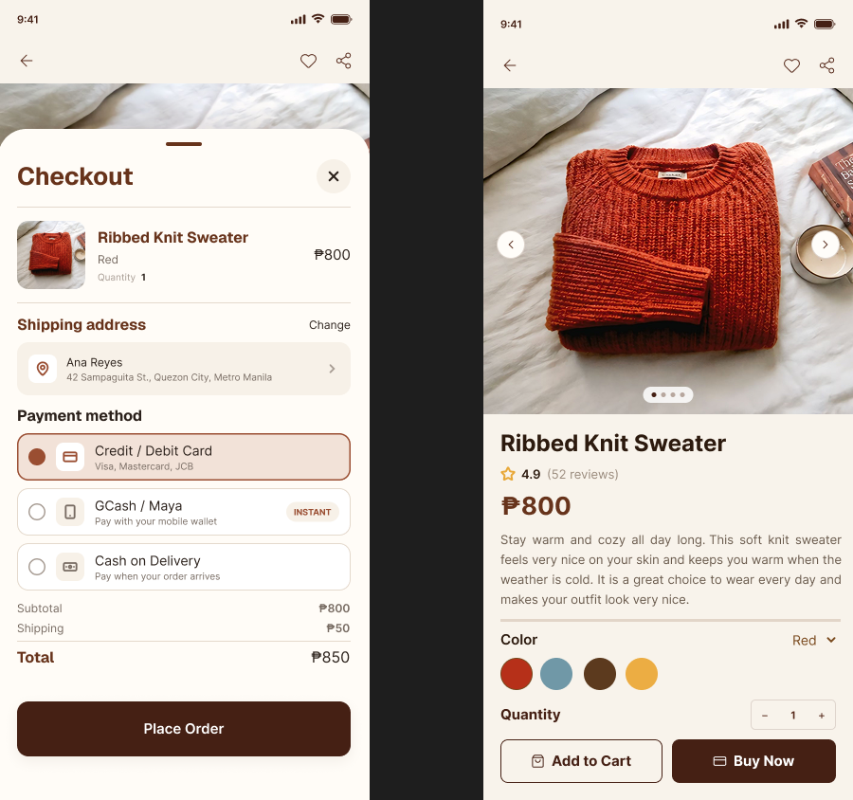
Figure 8. Mockups: Checkout sheet and Product Detail.
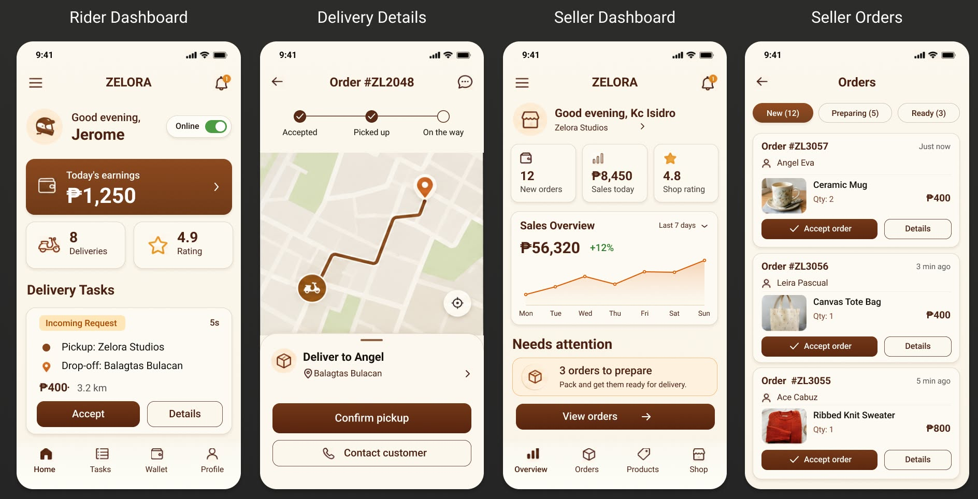
Figure 9. Mockups: rider’s dashboard, delivery details and seller’s dashboard and sellers orders

Color palette. The colors were taken from the final mockups and are defined once in colors.xml, with names that describe their role.
Color | Name | Hex | Used for
 | Cream | #F8F3EB | App background
 | Soft white | #FDFBFA | Cards, bottom navigation
 | Brand brown | #67331B | Headings, banner, selected chip, prices
 | Dark brown | #4B2215 | Primary buttons (Log in, Create Account)
 | Text brown | #572A1B | Labels and icons
 | Muted brown | #8B7468 | Subtitles and section labels
 | Beige | #F0DFC8 | Highlights, table headers, supporting items
 | Amber | #E4A853 | Rating stars
 | Orange | #D78A2C | Cart badge and notification dot
 | Selected brown | #9A4E32 | Selected payment option

Typography. Headings, titles and prices use Bricolage Grotesque (bold and semibold). Body text, labels and buttons use Inter (regular, medium, semibold and bold). Both are open-source fonts under the SIL Open Font License and are bundled in the app. Text sizes run from about 12 sp for helper text to 26 sp for screen titles.
Navigation structure. Each role has a short, flat navigation with at most four main destinations:
Role | Navigation
Customer | Bottom navigation: Home, Wishlist, Cart, Account. A side menu gives My Orders, My Account, Account Settings, Help Center, Terms and Conditions, and Log Out. Product Detail and the Checkout sheet open from Home and Cart.
Seller | Bottom navigation: Overview, Orders, Products, Shop. A top menu has Log out and a bell that shows how many orders are waiting.
Rider | Bottom navigation: Home, Tasks, Wallet, Profile. Delivery Details opens from a task card.
Admin | One screen with five tabs: Overview, Users, Orders, Disputes, Vouchers.

UI/UX decisions. The decisions below follow the required UI/UX principles:
Principle | How Zelora applies it
Consistency | The same colors, fonts, rounded buttons and card style are used in all four role apps. The seller and rider apps share one frame (header, page and bottom bar).
Usability | Short, clear labels such as Accept order, Mark ready, Confirm pickup and Place Order. Confirmation dialogs appear before steps that cannot be undone. Empty lists show a helpful message.
Visual hierarchy | Large bold titles and prices, small gray helper text, and one dark primary button per screen.
Accessibility | Dark brown text on cream gives strong contrast. Buttons and chips are tall enough to tap comfortably. Icons are paired with text labels.
Responsive layout | Layouts use match_parent, weights and scrolling, so they adapt to different phone sizes. Long screens scroll.
Feedback | Toast messages and field errors tell the user what happened. Notifications report order status changes.

4.2 Development Tools
Tool | Purpose
Android Studio | The primary Integrated Development Environment (IDE) used for code editing, emulator management, Logcat debugging, and building the application.
Gradle 8.9 with Android Gradle Plugin 8.7.3 | Builds the project and manages libraries.
Android Emulator / physical phone | Used to run and test the application. A physical Android device can also be connected through USB debugging.
Git and GitHub | Used for version control, source code management, tracking changes, and maintaining the project's repository.
draw.io and Graphviz | Used to create the system diagrams stored in the Zelora-Diagrams.drawio file.
‎Figma | Used to create UI/UX mockups and plan the application's screen layouts and navigation before implementation.

4.3 Technologies Used
Technology | Use in Zelora
Java 17 | Programming language of the application.
Android SDK (minSdk 26, targetSdk 34, compileSdk 35) | Platform APIs: activities, fragments, notifications, intents.
XML layouts | Screen designs and resources.
SQLite (SQLiteOpenHelper) | Local database with 13 tables, DAO classes and parameterized queries.
SharedPreferences | Logged-in user, shop name, rider online switch and last seen order status.
AndroidX AppCompat 1.7.0, RecyclerView 1.3.2, ViewPager2 1.1.0, Material Components 1.12.0 | UI components: lists, photo slider, dialogs, bottom navigation.
PBKDF2 with salt | Password hashing (100,000 iterations).
NotificationManager and NotificationChannel | Local order status notifications.

4.4 Major Application Screens
Zelora contains more than 20 screens organized into four user roles: Customer, Seller, Rider, and Admin. Each role has a dedicated interface designed to support its specific responsibilities. The application also includes shared Login and Sign Up screens. After logging in, users are directed to the home screen corresponding to their assigned role.
Screen | Purpose
Login screen | The Login screen allows registered users to access the application using their email address and password. It includes the Zelora logo, login fields, a login button, and a forgot-password option. Disabled accounts are refused access..
Sign Up Screen | The Sign Up screen allows new users to create an account and select an available role, such as Customer, Seller, or Rider. The form validates user input before registration. The selected role determines the interface and functions available after login.
Customer Screens | The Customer interface supports the complete online shopping process. Its bottom navigation bar provides access to Home, Wishlist, Cart, and Account.
Home Screen | The Home screen displays the product catalog and provides product search and category filters. Customers can browse available products and view their images, names, ratings, and prices.
Product Detail Screen | The Product Detail screen displays the selected product's photo gallery, description, available colors, and customer reviews. Customers can add products to their cart or wishlist and proceed directly to purchasing.
Wishlist Screen | The Wishlist screen displays products saved by customers for future reference, allowing them to keep track of items they may want to purchase later.
Cart Screen | The Cart screen displays the products selected for purchase. Customers can change quantities, remove items, and apply available vouchers before proceeding to checkout.
Checkout Screen | The Checkout screen presents the customer's shipping address, available payment methods, and order summary. It includes Cash on Delivery as a payment option and displays the relevant order details before the customer places an order.
Admin | Overview, Users, Orders, Disputes and Vouchers tabs.

5.CONCLUSION AND RECOMMENDATIONS

Project Accomplishments‎
The Zelora E-Commerce Mobile Application effectively integrates online shopping, product management, delivery, and administrative functions within a single Android platform. Developed in Java 17 using Android Studio, it features four user roles: Customer, Seller, Rider, and Admin. Customer functionalities include product browsing, order tracking, and reviews, while seller capabilities cover product and order management. Delivery functionalities enable tracking and earnings management. The admin interface aids in account and order monitoring. Key technologies used include SQLite for local storage and PBKDF2 for password security, with role-based access and workflow restrictions ensuring data protection. This project provided valuable insights into Java programming, Android development, and application security.
Problems Encountered
‎During the development of the Zelora E-Commerce Mobile Application, the developers encountered several technical challenges involving database persistence, registration, application logic, build configuration, and code syntax.
Database and Account Registration Errors‎
‎One of the main problems encountered was that registered accounts and other data were not consistently saved or retained, particularly when the application depended on a connected development environment. Database-related errors also occurred during registration, causing some account creation attempts to fail. These problems made it difficult to ensure consistent account storage and reliable registration.‎
‎Logical Errors in the Checkout Process‎
‎Another problem involved the order status during checkout. In some cases, an order was automatically marked as Delivered immediately after checkout, even though the delivery process had not yet taken place. This resulted in an incorrect order status and affected the expected sequence of order processing and delivery.
‎Gradle Build Errors and Hardware Limitations‎
The project also encountered numerous Gradle configuration and build errors. These issues were more challenging to troubleshoot because the development laptop had limited hardware resources. The laptop's performance limitations affected the development workflow and made building, debugging, and resolving project configuration issues more difficult.
‎Syntax Errors and Comment Formatting Issues
‎Syntax errors also occurred during coding, particularly when comments became mixed with code or were incorrectly formatted. These mistakes sometimes caused compilation errors or made the source code more difficult to read and maintain. Identifying and correcting these errors required additional code inspection and debugging.

‎These challenges highlighted the importance of reliable data persistence, correct application logic, proper build configuration, sufficient development resources, and careful code organization when developing an Android application.
Recommendations and Future Improvements
‎Based on the problems encountered during development, the following improvements are recommended for future versions of Zelora.‎
‎Improve Database Persistence and Registration Reliability
‎The database implementation should be reviewed to ensure that registered accounts and other important records are saved consistently and remain available after the application is closed or reopened. Registration validation and database operations should also be improved to prevent failed account creation and provide clear error messages when a database operation is unsuccessful. If the application is intended to support account access across multiple devices, a properly configured remote database or backend service may be considered.
Correct the Checkout and Order Status Workflow
‎ The checkout process should be improved to ensure that placing an order does not automatically mark it as Delivered. Order statuses should follow the intended workflow, such as Processing, Preparing, Packed, and Delivered, with each transition occurring only after the appropriate action has been completed. Testing should cover checkout, order acceptance, preparation, pickup, and delivery to ensure that order records remain consistent throughout the process.
‎Optimize Gradle Configuration and Development Performance
‎The Gradle configuration and project dependencies should be reviewed to resolve build errors and improve build reliability. Unnecessary dependencies and background processes should be minimized where possible. Future development may also benefit from using a laptop with better hardware specifications to improve build times, emulator performance, and debugging efficiency.
‎Improve Code Quality and Error Prevention
‎The source code should be organized using consistent naming conventions, indentation, and comment formatting. Comments should be separated properly from executable code, and the application should be compiled regularly to detect syntax errors early. Code reviews, debugging tools, and automated tests can also help identify errors before they affect application functionality.
‎Strengthen Security and Data Validation
‎ Future versions should continue improving authentication, role-based access controls, input validation, and protection of user information. Database operations and sensitive functions should verify that users are authorized to perform the requested actions. Error handling should also avoid exposing sensitive information.
‎Enhance Delivery and Mapping Features
‎The rider's map placeholder may be replaced with an integrated mapping service that supports real location information and navigation, subject to available resources and permissions. The delivery workflow should continue to enforce pickup confirmation before completion and prevent multiple riders from claiming the same delivery.
Improve Rider Earnings Management
‎ The current flat rate of ₱40 per delivery is an application-defined value and does not represent actual payroll. Future improvements could introduce configurable delivery rates, more detailed earnings reports, and a clearly defined payment calculation system if the application is expanded for real-world operations.
Conduct Comprehensive Testing
‎ Future development should include systematic testing of registration, login, database persistence, product management, checkout, order status transitions, seller permissions, rider assignments, notifications, and administrative functions. Testing on both an Android emulator and physical devices can help identify compatibility issues and improve overall application reliability.
‎By addressing these recommendations, future versions of Zelora can become more reliable, maintainable, secure, and suitable for a broader range of users and devices.

APPENDICES

Appendix A. Final Application Screenshots
Insert your own emulator or phone screenshots of the finished app in the boxes below (one screenshot per box).
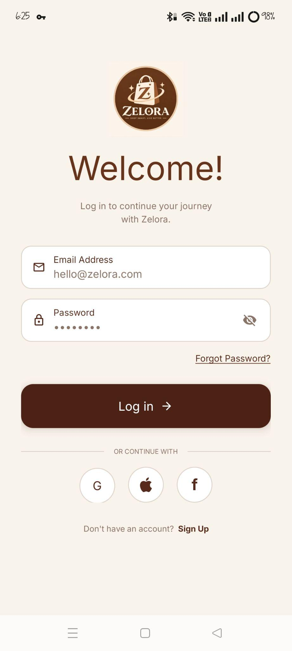Login | 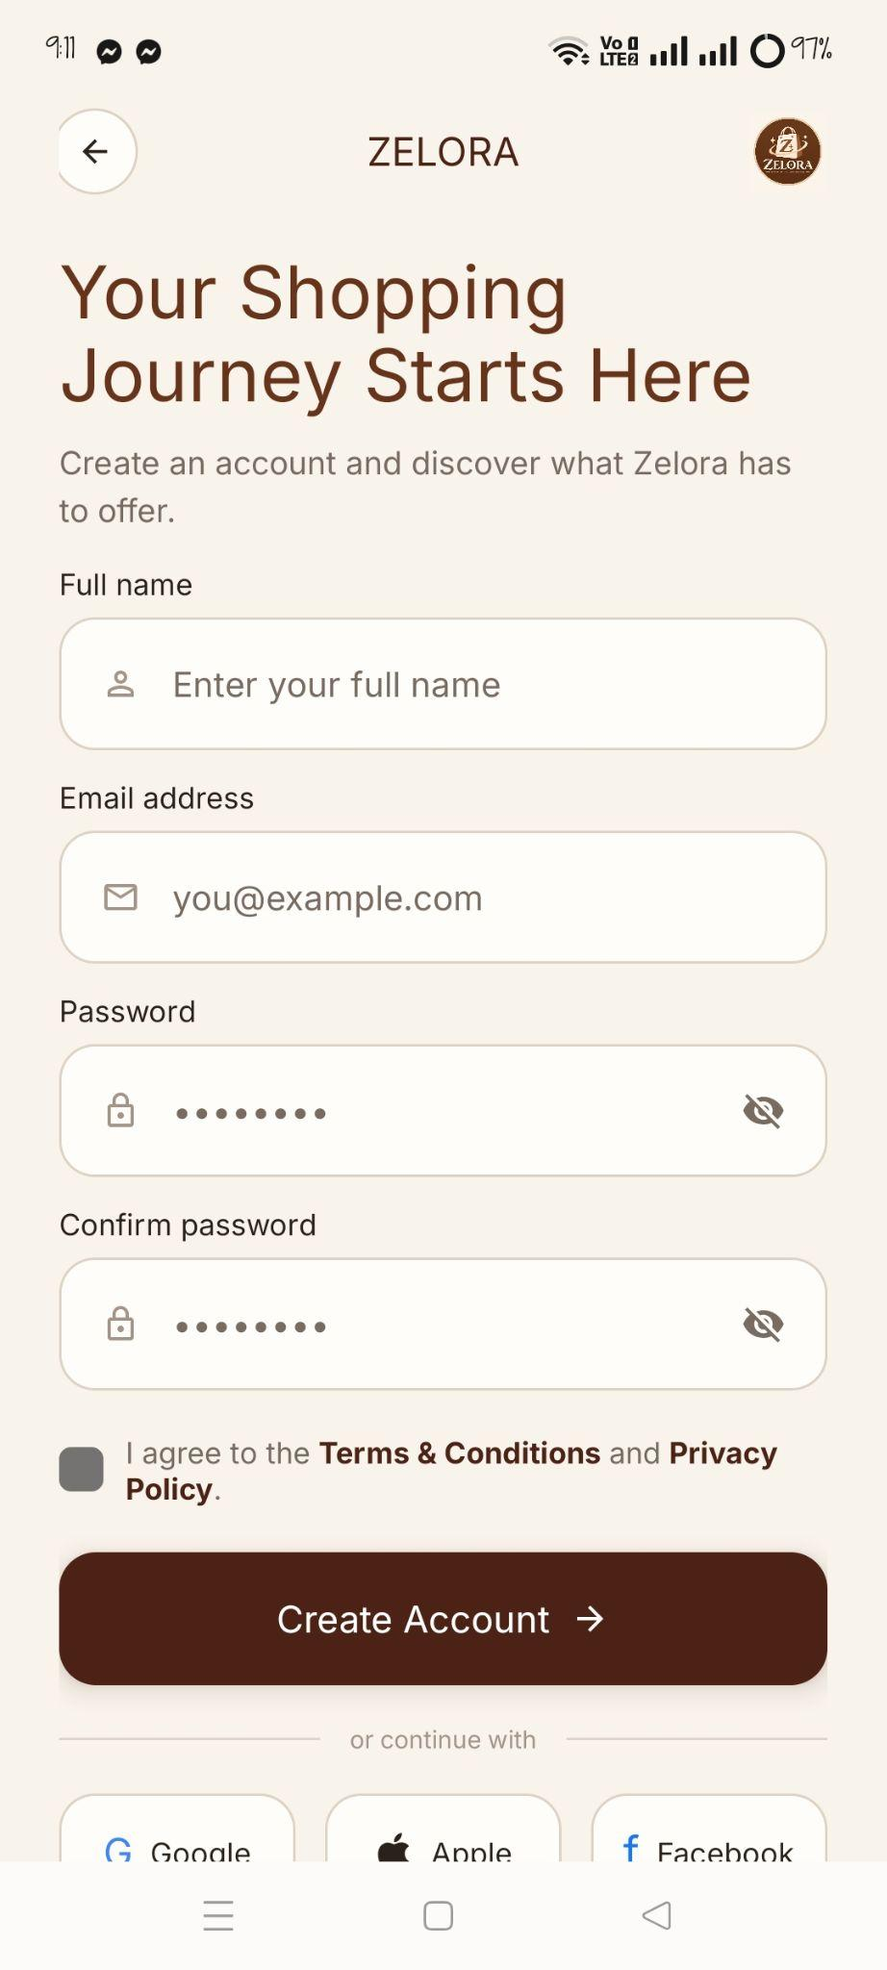  Sign Up
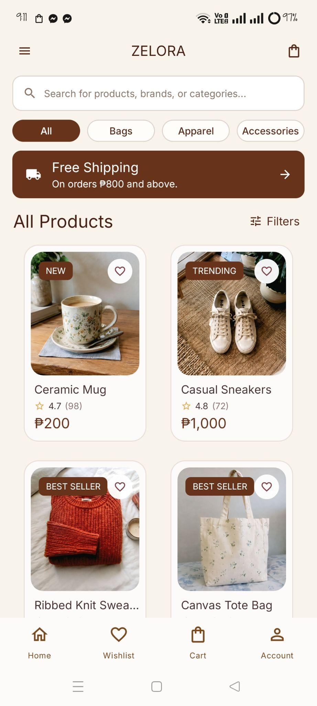  Home | 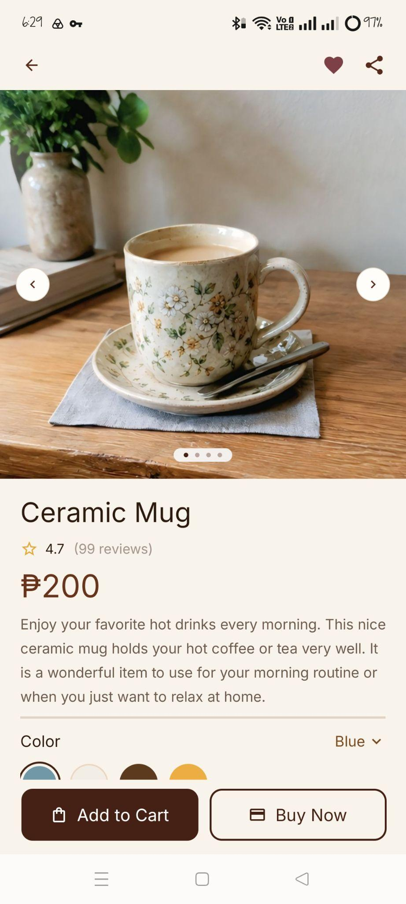  Product Detail
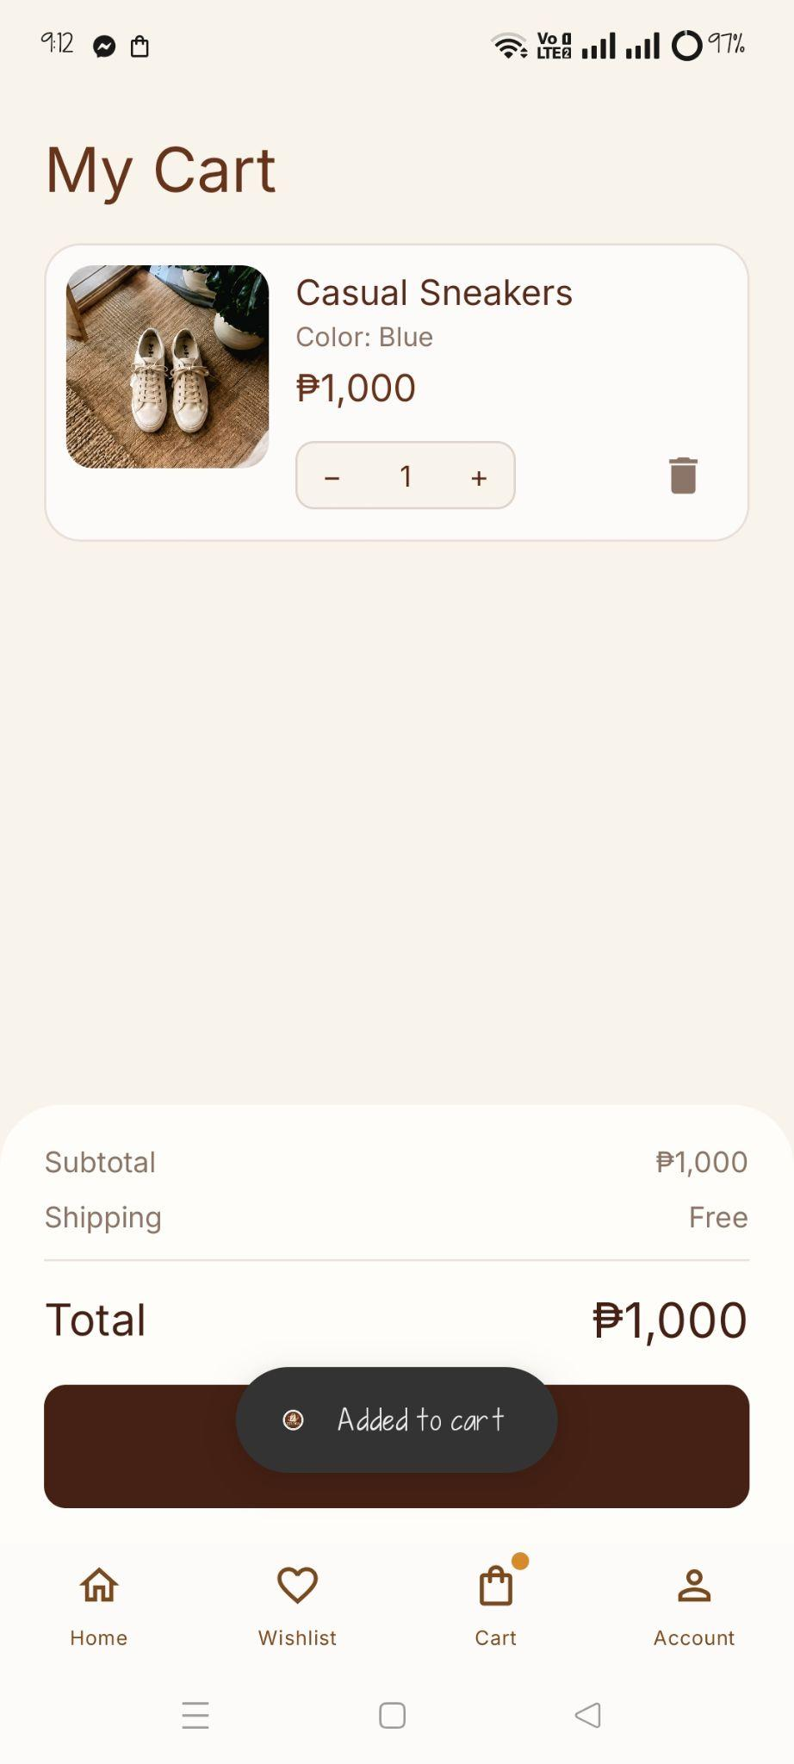  Cart | 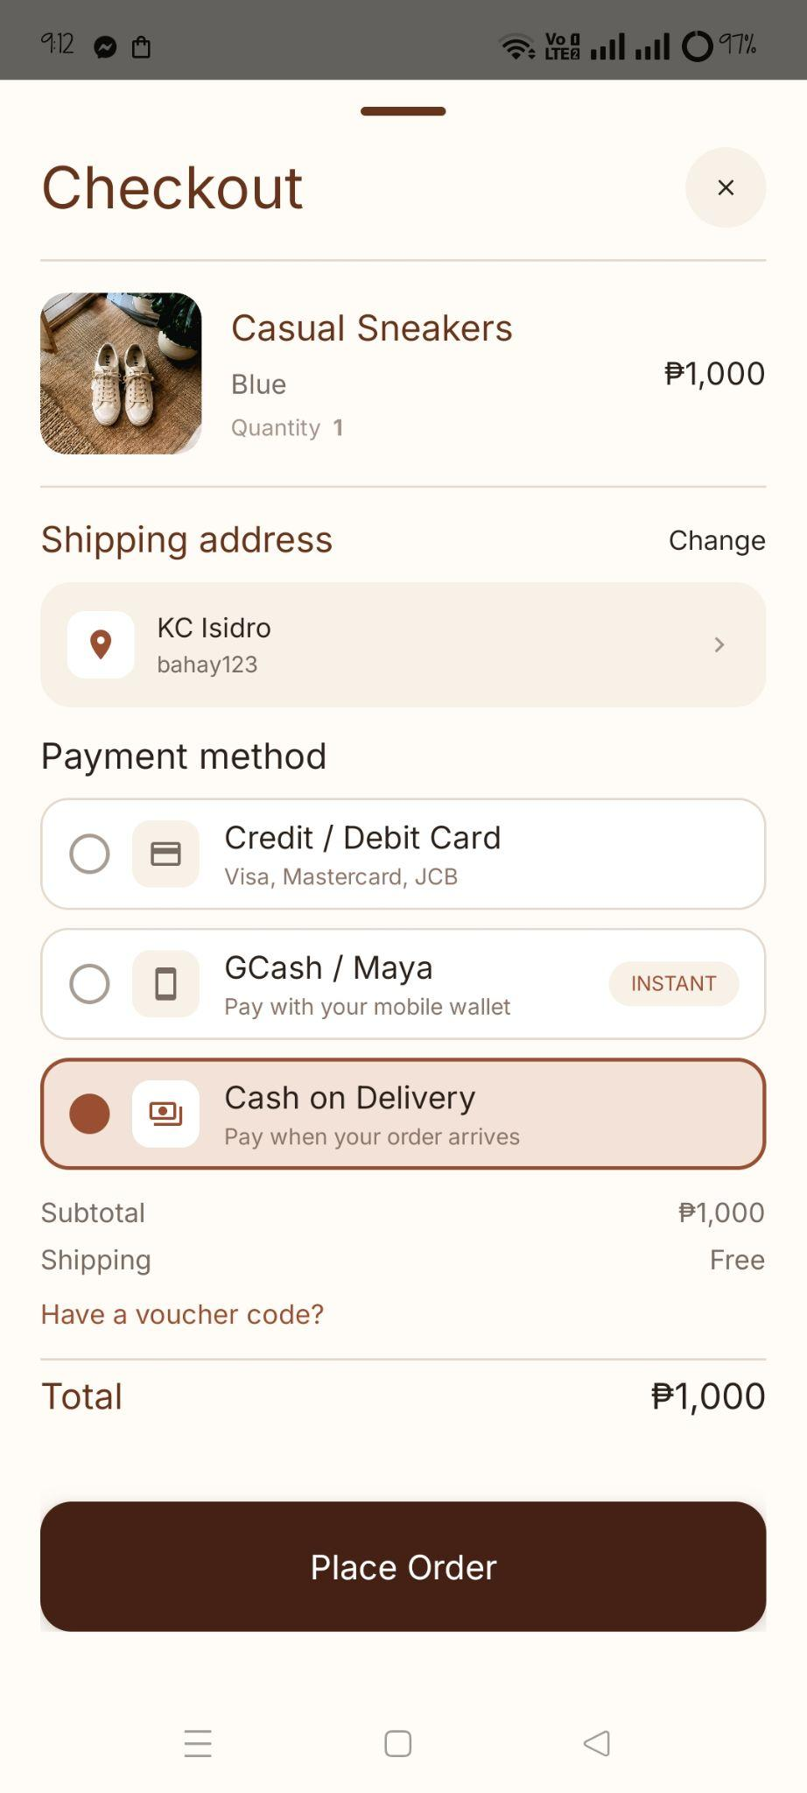Checkout
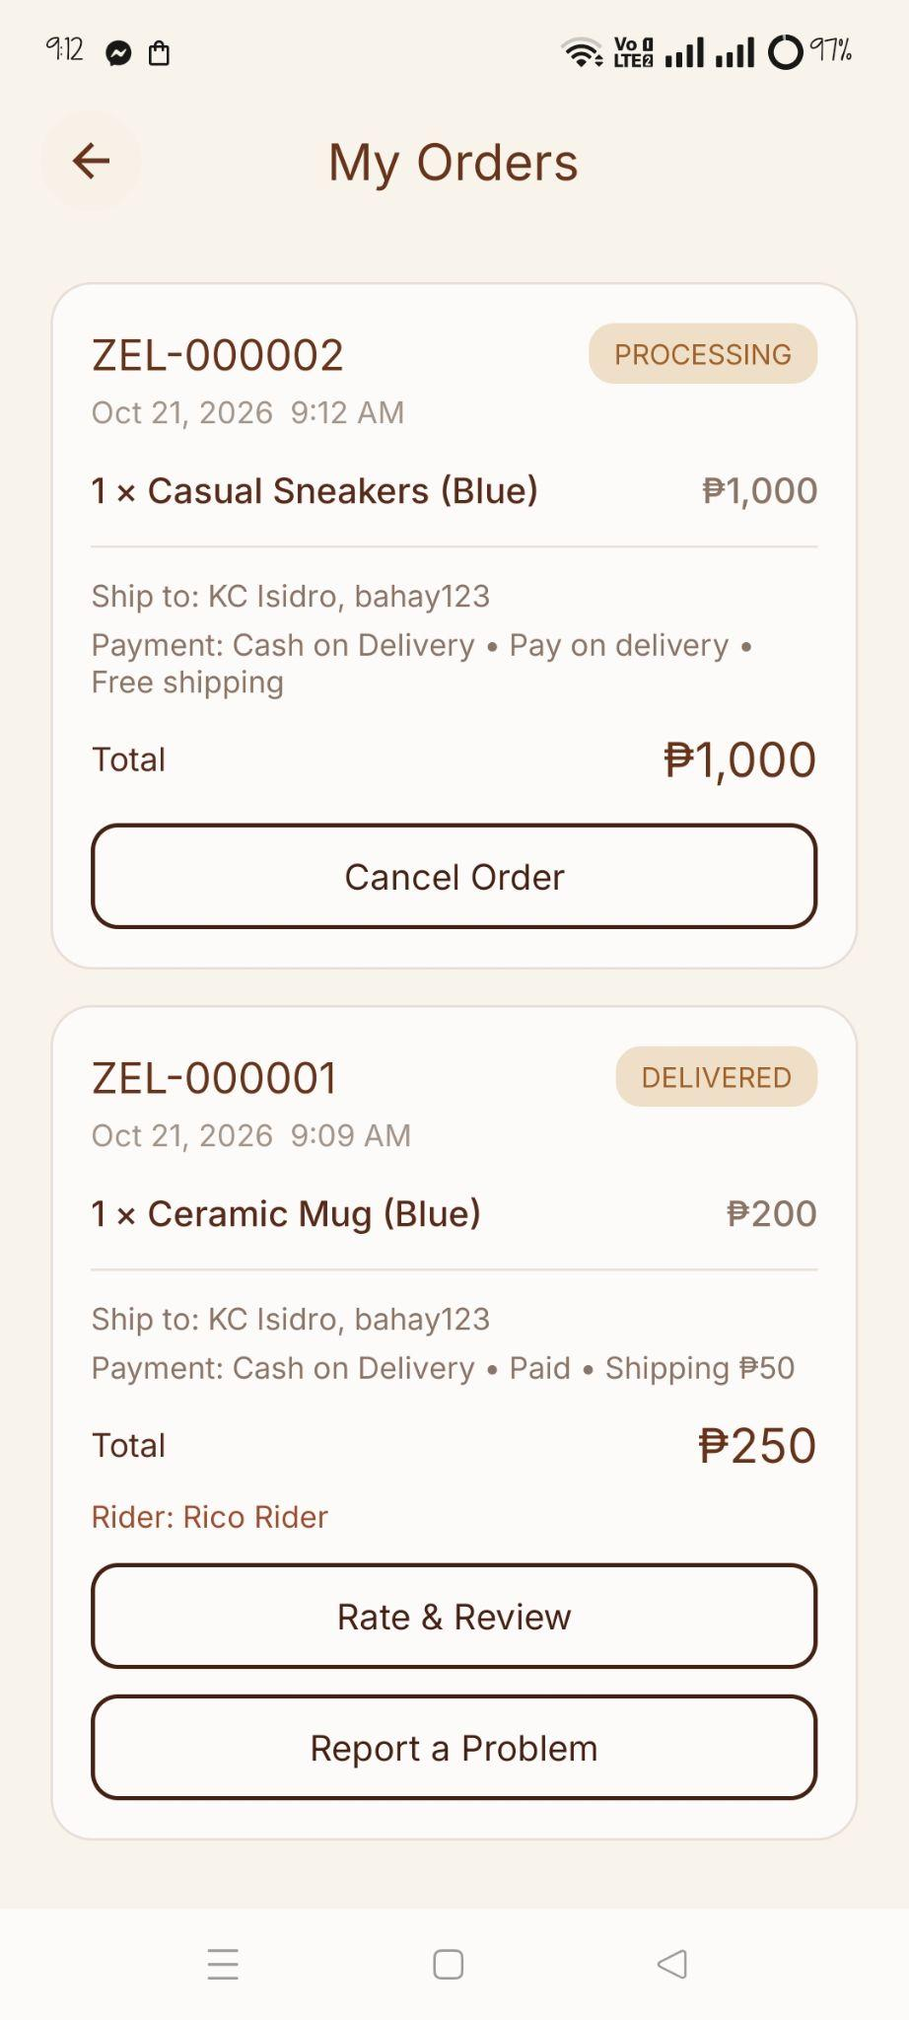  My Orders (with status) | 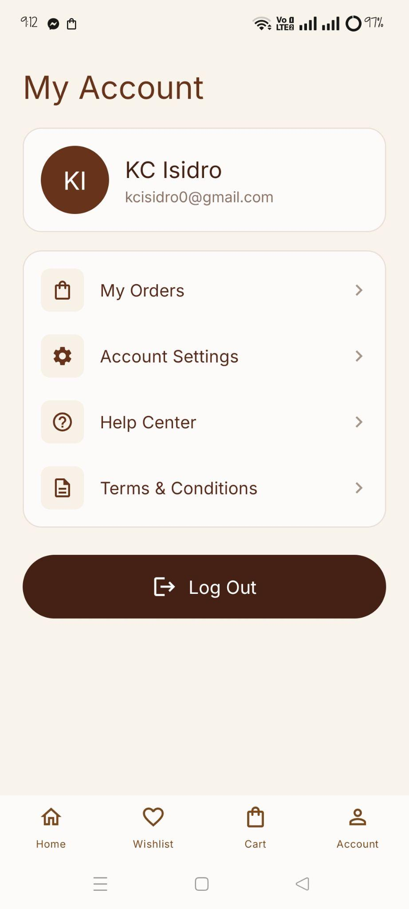  Account
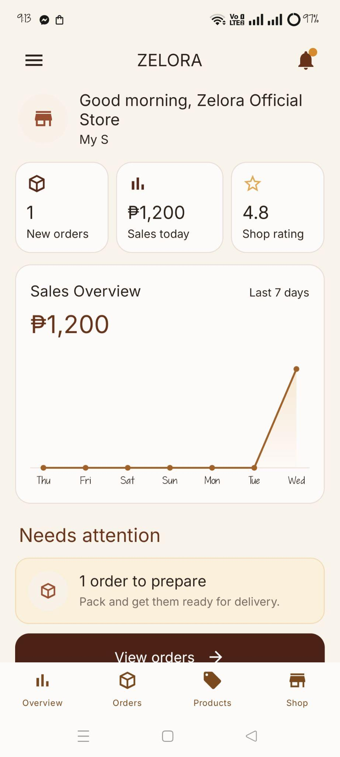  Seller Overview | 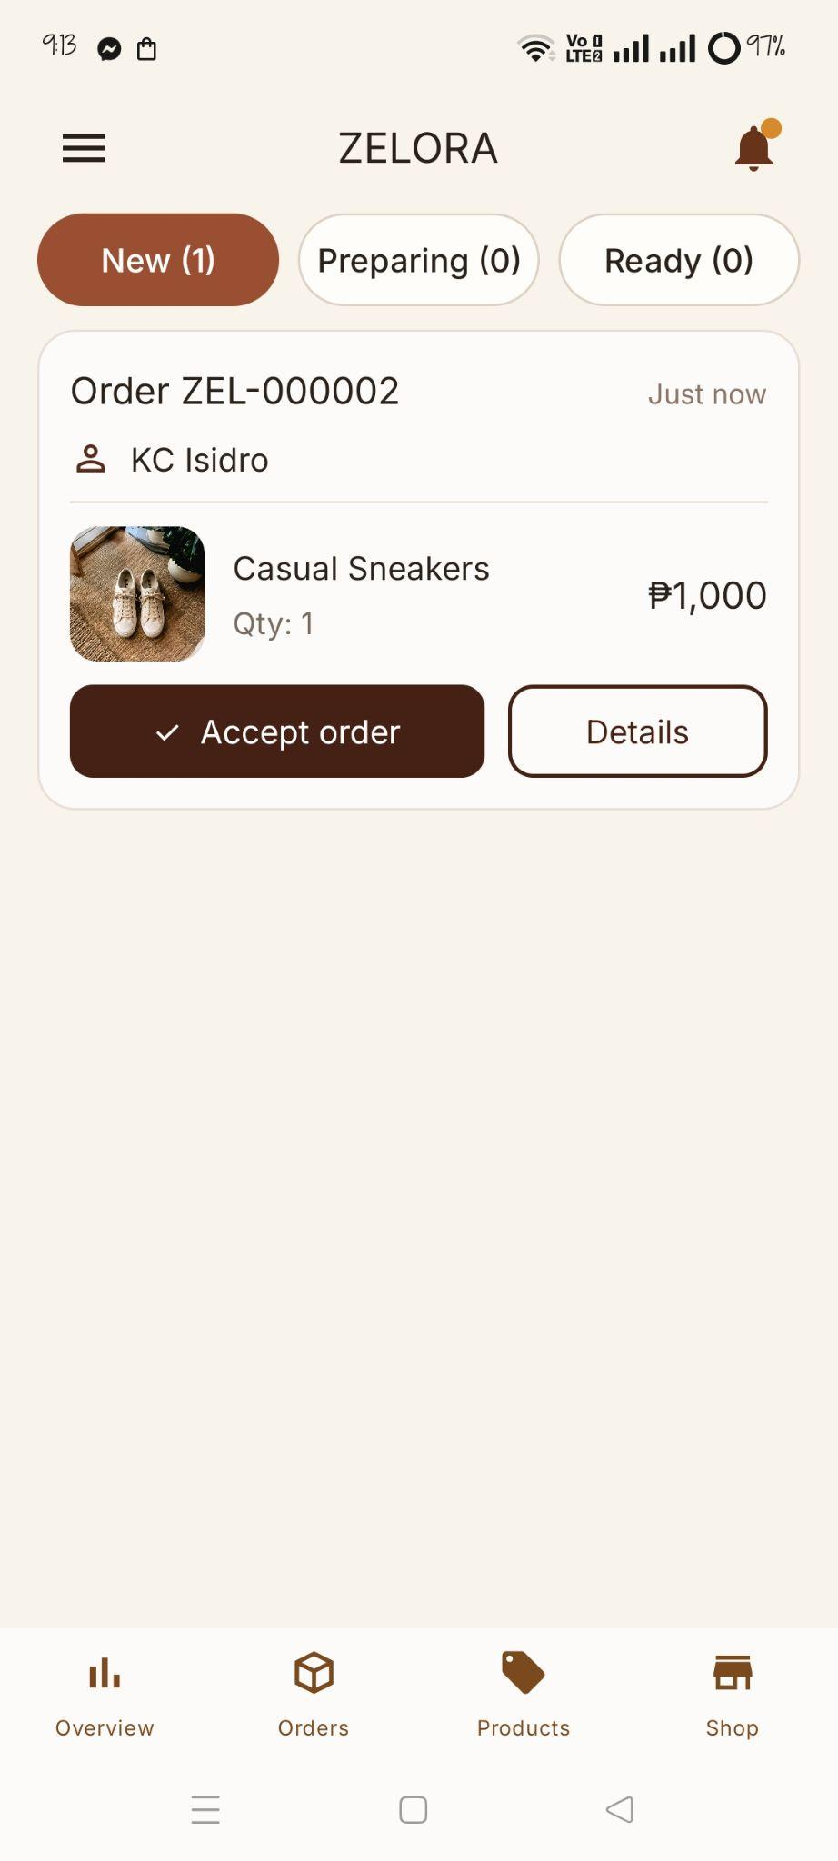Seller Orders
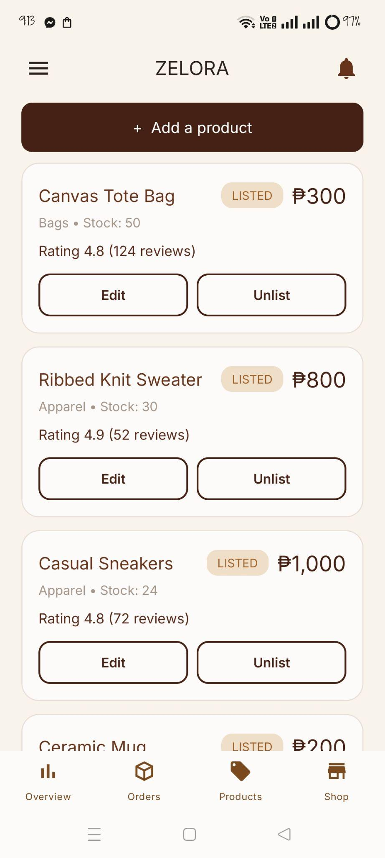  Seller Products | 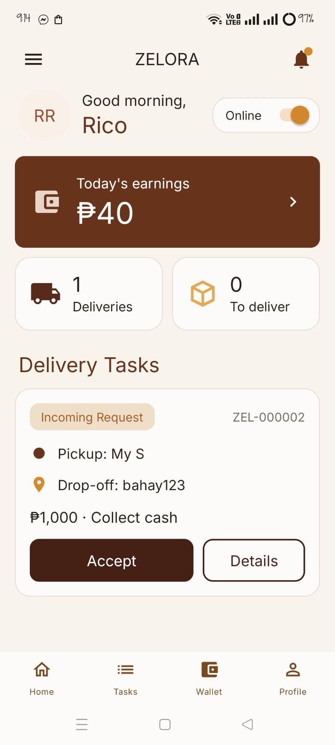  Rider Home
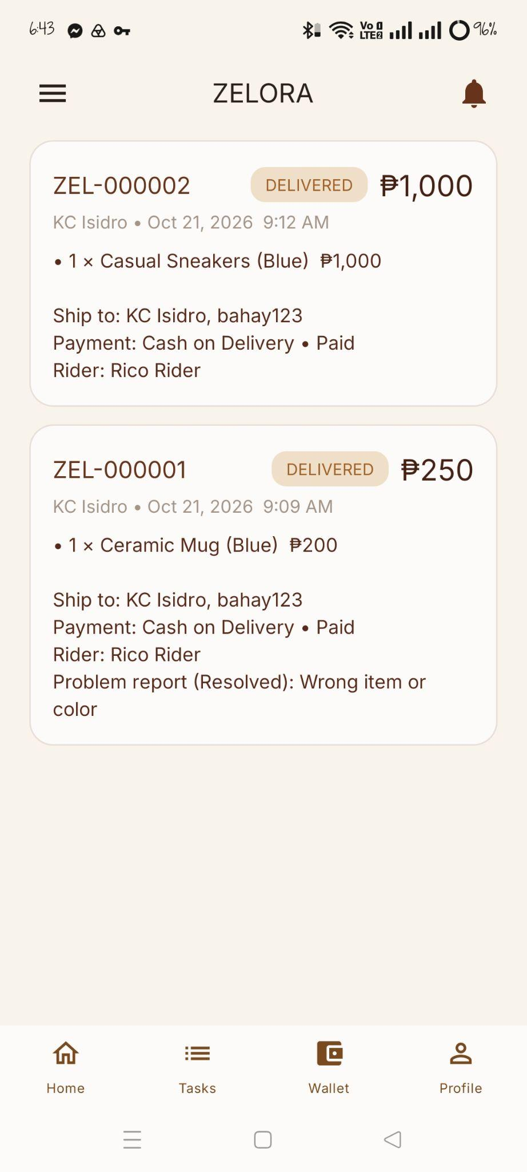Rider Delivery Details | 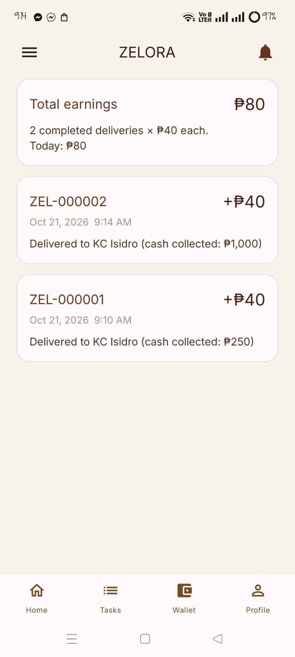  Rider Wallet
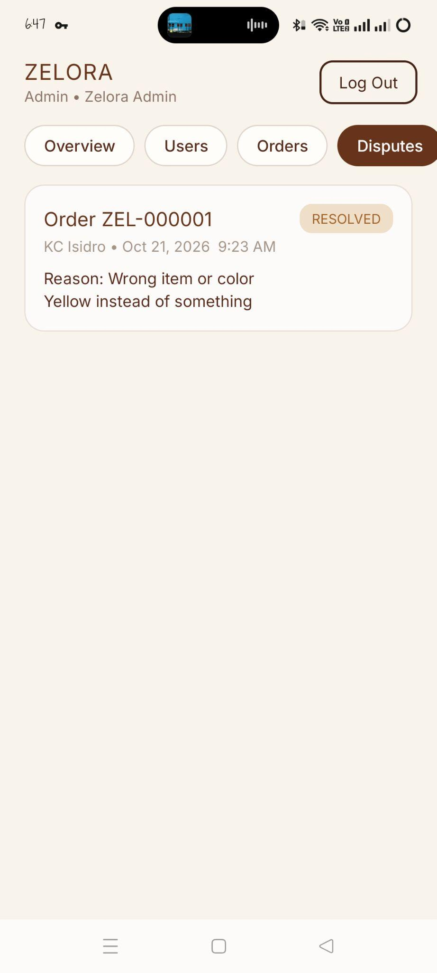  Admin Disputes | 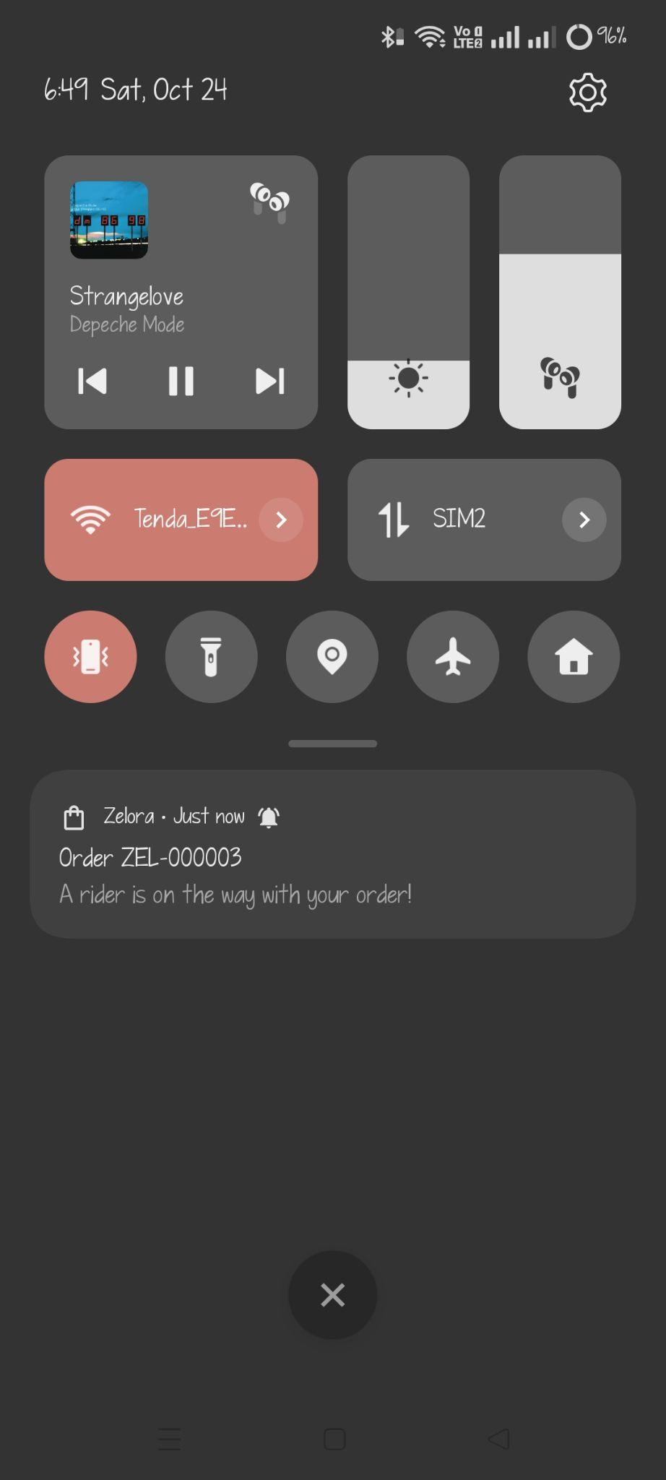  Order notification

Appendix B. GitHub Repository and Installation
Repository URL: []
The repository contains the source code, README.md (description, features, technologies, installation, screenshots, developers and version), the design mockups, and the system design diagrams.
Installation. Open the Zelora folder in Android Studio, wait for Gradle Sync, choose an emulator (API 26 or newer) or a phone with USB debugging, and press Run. To build an APK: Build → Build Bundle(s)/APK(s) → Build APK(s).
Demo accounts. Customers sign up in the app. Staff accounts are created automatically on first launch:
Role | Email | Password
Seller | seller@zelora.com | Seller1234
Delivery Rider | rider@zelora.com | Rider1234
Admin | admin@zelora.com | Admin1234

Vouchers to try: WELCOME10 (10% off), SAVE100 (₱100 off orders of ₱1,000 or more) and FREESHIP (free shipping).

Appendix C. Acknowledgments and Third-Party Resources
- Fonts: Inter (Rasmus Andersson) and Bricolage Grotesque (Mathieu Triay), SIL Open Font License.
- Libraries: AndroidX (AppCompat, RecyclerView, ViewPager2, Fragment) and Material Components for Android, Apache License 2.0.
- Product photos, logo and mockups: the project author.
- Diagrams were produced with Graphviz and draw.io.
Use of AI tools. As allowed by the project instructions, an AI assistant (Claude, by Anthropic) was used as a development and learning resource to help write, review and test parts of the code and documentation. The author reviewed the code and is able to explain how it works.

